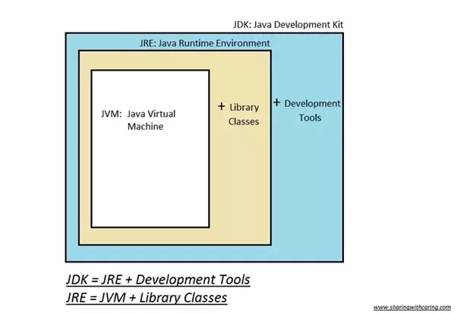

**JDK**

The Java Development Kit (JDK) is a software development environment used for developing Java applications and applets. It includes the Java Runtime Environment (JRE), an interpreter/loader (java), a compiler (javac), an archiver (jar), a documentation generator (javadoc) and other tools needed in Java development.Hence, JDK is a kit(or package) which includes two things i) Development Tools(to provide an environment to develop your java programs) and ii) JRE (to execute your java program). JDK is only used by Java Developers.

**JRE** :- Java Runtime Environment (to say JRE) is an installation package which provides environment to only run(not develop) the java program(or application)onto your machine. Hence, JRE is only used by them who only wants to run the Java Programs i.e. end users of your system.

**JVM** :- Java Virtual machine(JVM) is a very important part of both JDK and JRE because it is contained or inbuilt in both. Whatever java program you run using JRE or JDK goes into JVM and JVM is responsible to execute the java program line by line hence it is also known as interpreter. Hence you don’t need to install JVM separately into your machine because it is inbuilt into your JDK or JRE installation package.